**Project Report**

**INTRODUCTION**

**1.1 Overview**

Fashion Haven is an online retail store. There are a lot of websites on internet. Whereby it offer a variety of product and services for consumer as shoe, apparel, sunglass etc.We are looking the problem addressed in this research which is the view of online shopping by customer.

* 1. **Purpose**

Fashion can have various uses and purposes, both on an individual and societal level. Here is some of the common uses fashion:

**1. Self-Expression**

Fashion allows individuals to express their personality, creativity and individuality through clothing and personal style. It can be a form of self-identity and a way to communicate one’s values and beliefs

**2. Cultural Representation**:

Fashion often reflects cultural traditions, values and trends. It can be a powerful tool for representing one’s cultural heritage and celebrating diversity.

**3. Confidence and Self-Esteem:**

Wearing fashionable and well-fitting clothing can boost a person’s confidence and self-esteem, leading to a positive self-image.

**4. Communication and non-verbal Language:**

Clothing and style can convey messages without words. It can signal one’s mood, intentions or status and it’s often used in non-verbal communication.

**5. Social Change and Activism:**

Fashion has been used as a tool for social and political activism. Clothing and accessories can carry messages or symbols that raise awareness of various causes.

**2. Problem Definition & Design Thinking**

**2.1 Empathy Map**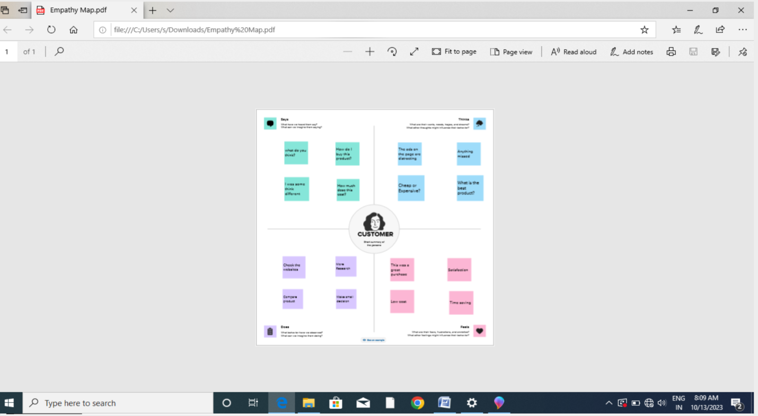

**2.2 Ideation & Brainstorming Map**

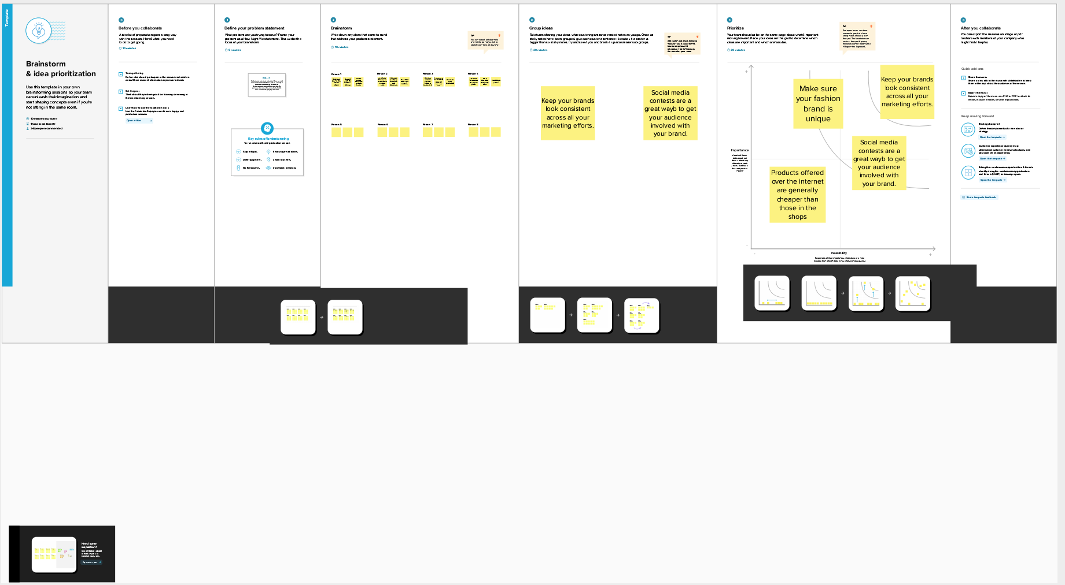

**3. RESULT**

**Profit & Loss**

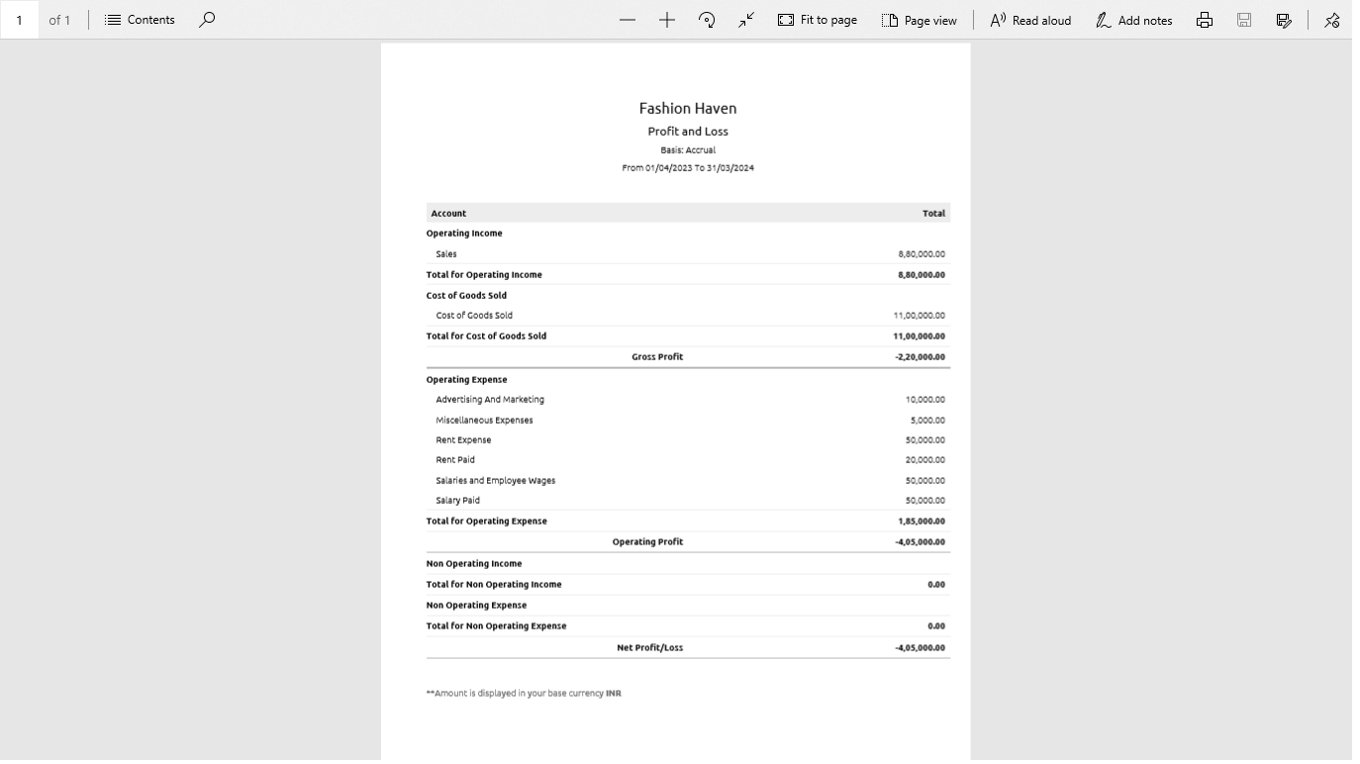

**Balance Sheet**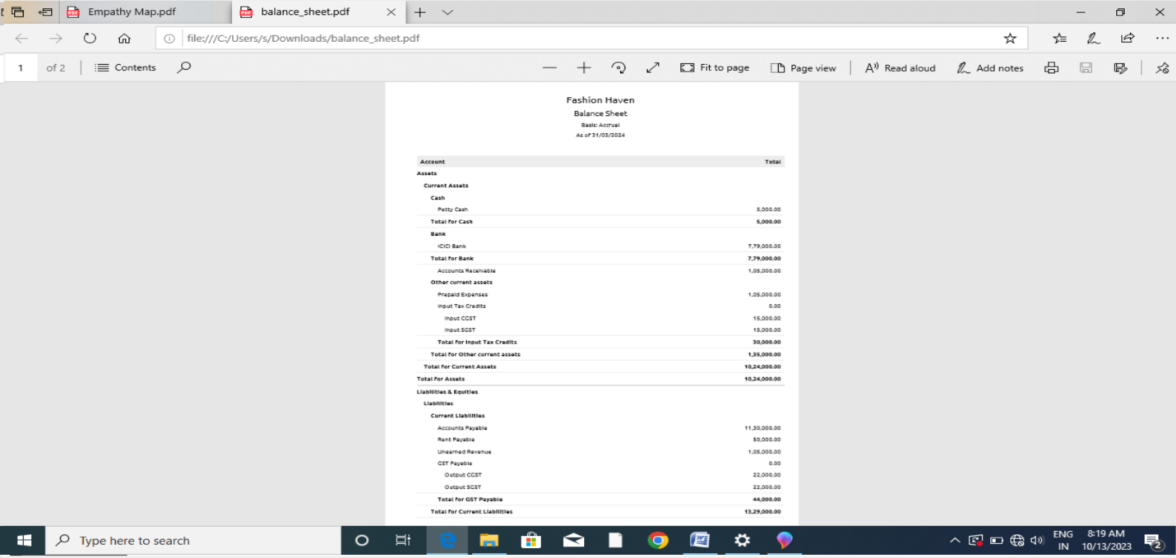

**4. Advantages & Disadvantages**

**Advantages**

**1. Style Inspiration:**

Fashion havens are often filled with stylish individuals, which can be a great source of inspiration for those looking to enhance their own fashion sense.

**2. Shopping Opportunities:**

These Places typically have a wide range of fashion boutiques and stores, making it convenient for fashion enthusiasts to discover unique and trending and accessories.

**3. Networking:**

Fashion haven are excellent places for networking with like-minded individuals in the industry. Whether you’re a designer, model or fashion blogger.

**4. Artistic Community:**

They often attract a creative community, fostering collaboration and innovation within the fashion and design fields.

**5. Economic Impact:**

Fashion districts can boost the local economy through increased tourism, retail sales and job creation.

**Disadvantages:**

**1. Cost:**

Keeping up with the latest trends can be expensive, leading to financial strain for many.

**2. Environmental Impact:**

The Fashion industry is a major contributor to pollution and waste, which harms the environment.

**3. Waste:**

Rapidly changing trends lead to the disposal of clothing, contributing to the problem of textile waste.

**4. Body Image Concerns:**

Fashion can promote unrealistic body ideas, leading to body image issues and low self-Esteem.

**5. Social Pressure:**

Conforming to fashion standards can create social pressure to fit in or be accepted, leading to a lock of individuality.

**5. APPLICATIONS**

**1. Design and Trend Analysis:**

It can help analyze data to identify emerging fashion trends and consumer preference.

**2. Inventory Management:**

Optimizing stock levels based on demand forecasting and sales data.

**3. Personalized Recommendations:**

Providing tailored product recommendations to customers based on their preference and browsing history.

**4. Pricing and Promotion Optimization:**

Setting optimal pricing and promotion strategies using data analytics.

**5. Supply Chain Management:**

Enhancing the efficiency of the supply chain, from sourcing materials to distribution.

**6. E-Commerce Enhancements:**

Improving online shopping experiences through data-driven features.

**7. Marketplace Operations:**

Managing and optimizing operations on online marketplace.

**6. CONCLUSIONS:**

The Conclusions of a concept called Fashion Haven” could vary depending on its context. Fashion Haven “might refer to a hypothetical ideal place or concept related to fashion. In conclusions, zoho books are cost effective and efficient accounting software that offers a wide range of features to simplify your financial management processes.

**7. FUTURE SCOPE:**

**1. Sustainability:**

Consumers are increasingly concerned about the environmental impact of the fashion industry. Brands that adopt sustainable and eco-friendly practices are likely to see growth.

**2. E-Commerce:**

Online Shopping continues to grow, and businesses that have a strong online presence can tap into a global customer base.

**3. Inclusivity and Diversity:**

Brands that promote inclusivity and diversity in their products and marketing or likely to resonate with a wider audience.

**4. Circular Fashion:**

Embracing circular economy principles, such as recycling and up cycling, can be a sustainable approach for the future.

**5. Niche Markets:**

Targeting specific Niche markets or segments within the fashion industry can lead to success, as consumers seek unique and specialized products.